## QUICKER SOLUTION ##

NOTE: IF you don’t want to spend the time to make the certificate yourself, then just scroll down to the end of the document and download the one I created for you; Then, follow the instructions from step 4) onward!

For everyone else, follow the tutorial from the start (it’s easy and takes like 2 minutes);

## GIT BASH CERTIFICATE CREATION TUTORIAL ##

1) Download Git Bash Portable (64bit) here:
https://git-scm.com/downloads/win

2) Extract the archive and launch git-bash.exe (could need admin rights, depending on your system);

3) Copy the code below, then in Git Bash do a Right Mouse Click > Paste (You can also type it in manually, but make sure to only use spaces and no “new line breaks” between the code elements!);

CODE TO PASTE:

echo 'quit' | openssl s_client -showcerts -servername 'pub-sc-alpha-410-9650658.test1.cloudimperiumgames.com' -connect 'pub-sc-alpha-410-9650658.test1.cloudimperiumgames.com:443' -certform der -keyform der > cacert.crt

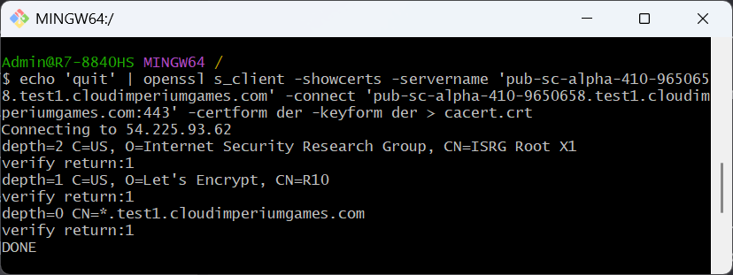
^THIS IS HOW IT SHOULD LOOK LIKE AFTER YOU PASTE THE CODE AND PRESS ‘ENTER’!

IMPORTANT NOTE: For any future patch versions, just replace the “410-9650658” part of the code with the current patch’s version numbers! This works for PTU too!!!
EXAMPLE: 'pub-sc-alpha-410-9650658.test1.cloudimperiumgames.com < only touch the green part with the version numbers; Replace BOTH instances of them in the code!

To find the current version, just take a look in the RSI Launcher:
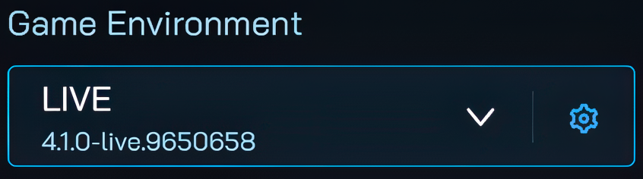
Now, after you’ve created your certificate, let’s import it!

4) Open Windows Certificate Manager (press Windows Key + R for the ‘Run’ command) and type in: certmgr.msc

5) On the left pane, navigate to Trusted Root Certification Authorities > Certificates > Import > and browse to your cacert.crt file (located in the Git Bash folder);

## ADDITIONAL NOTES & TROUBLESHOOTING ##

- If Git Bash gives you an error, then you haven’t typed out the code correctly -OR- the Star Citizen servers might be down, so you’ll have to wait; A certificate can only be created if there are actual running servers for Git Bash to connect onto!
- If a newer version of Star Citizen has come out (and I haven’t updated the code here), then the server version will have to be changed (the green numbers only, with the current version)!
Just do that and your certificate will be created (unless CIG’s servers are down, ofc);
- I’ll try to maintain this document for a time, but no guarantees that I’ll be able to always react quickly when a new patch comes out; Same goes for the certificate link!

For any further questions, drop them in the comments section below the video and I'll try to help you out! As always, thanks for watching and I’ll see you guys in the next one!

YouTube Link: Star Citizen: How To Fix Error 19000 & Log Back In! (100% Working Fix)
Certificate Link: cacert.crt
SC LIVE Version: 4.1.0-9650658
Last Updated: 01-Apr-25;

